HEALTH HABITS LESSON NOTES
TOP CLASS TERM I 2026
LESSON NOTES FOR LEARNING AREA 3 (HEALTH HABITS)
FOR TOP CLASS TERM I.
Taking care of myself for proper growth and development.
My name is
I am years old. I am a (girl, boy)
My father’s name is My mother’s name is I live/stay at
My school is
Activity
- What is your name?
My name is
- How old are you:
I am years old.
I am a (girl/boy) Let the pupils talk about themselves.
- What’s your father’s name?

- What’s your mother’s name?

- Where do you live/stay?

- What’s the name of your school?

Drawing and describing his/her name.
Naming my body parts
  - Reciting/singing a rhyme about body parts.
  - Naming and identifying body parts e.g. ears, toes, nose,
mouth, fingers, legs, eyes, lips, etc.

Teacher leads pupils to know how many they are.
All about functions of each body part e.g.
Eyes - seeing
Nose - smelling Legs - walking, etc.
- Children should know the main function of body parts. i.e. to give shape of person.
The teacher should lead the pupils to appreciate the gifts God
gave us through a song, prayer, rhyme, etc.
Activity
- Teach a dialogue song about body parts (oral)
- Naming body parts.
 |  |  |  | 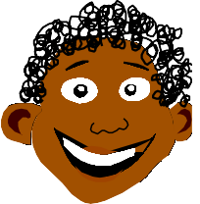
 |  |  |  | 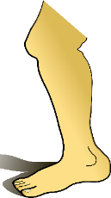
 |  |  | 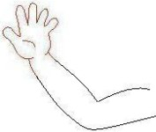 | 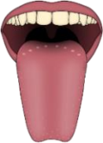
 |  |  |  | 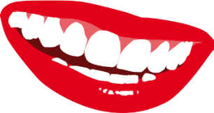
 |  |  | 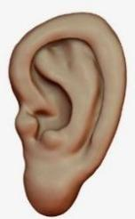 | 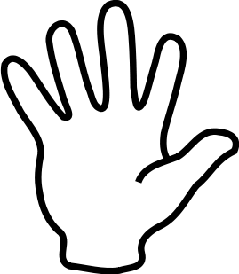

Matching body parts to their uses.

Walking Hearing

Seeing Smelling Touching
Filling in missing letters
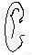 e r 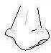 n se le 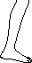 Write these words correctly.
era seno eey
ige teos ngerfi
Caring for our body
Reciting a rhyme about the ways of caring for our body.
Teacher guides children and instructs them to mention the way how different body parts are cared for. e.g
Teeth - by brushing Fingernails - by cutting them short
Hair - by combing, cutting, plaiting, etc.
Activity
How can you care for your teeth?
I can care for my teeth by _
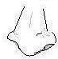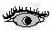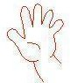

Draw these things we use to cut finger nails.
(i) razorblades (ii) nail cutter
Match correctly

Toothbrush

Comb
Razorblade Toothpaste
- Talk about the importance of keeping our body clean e.g. It makes us look smart, etc.
- Talk about the dangers of cleaning the body. e.g. It causes bad smell.
- I can locate the place where I live/stay
I live/stay at My village is . My home is found at Things that make up a home.
Kitchen Toilet Bedroom Bathroom Sitting room Activity
- Name the things found in the kitchen e.g. saucepan, spoon, and plates.

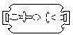
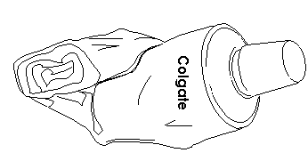

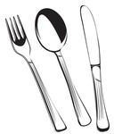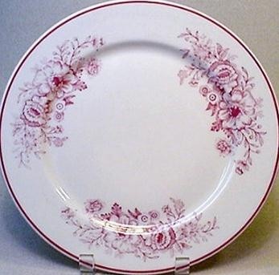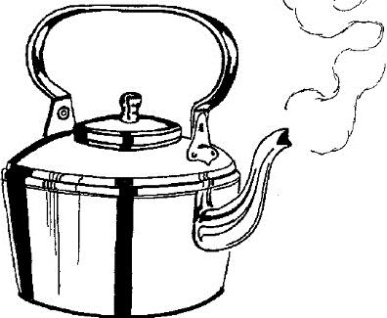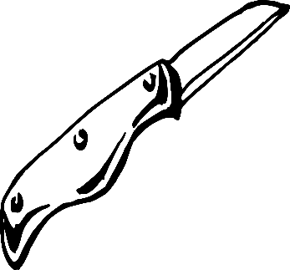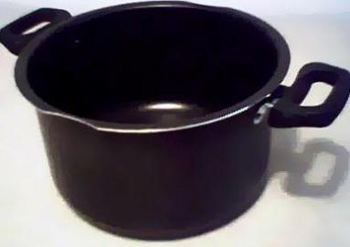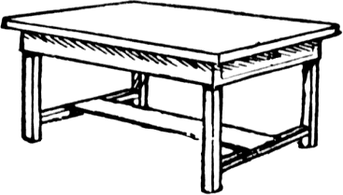
Where do we ease? (Oral)
Chairs, cupboard, table, carpet, television, (TV), radio, etc
- Write the things we find in a bedroom. e.g bed, basin, wardrobe, mattress, blanket, pillow, suitcase, etc
- Family members
- Recite a rhyme/sing a song about family members.
- Mention family members (nuclear family) e.g father, mother, sister, and brother, baby
Other family members extended family)
- aunt
- uncle
- cousin
- nephew
- grandfather
- grandmother
Activity
Who heads a family?
heads a family.
Things found in the | kitchen.

 |  | Name these people found at home.
 |  |  | 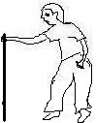 | 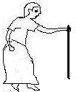 | 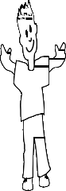
Fill in the missing letters
f ther m ther si ter br_ther Color these family members
Animals found at home.
- pig
- goat
- dog
- sheep
- cow
- rabbit
Activity
Write these words correctly. pgi -
gdo - oatg- _ atc - woc - eepsh- bbitra-_

Read and | draw
pig | dog | cow | sheep | rabbit | cat

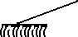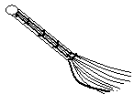Fill in missing letters.
sh p go t c w rab it c t
- Telling the role of each of the animal found at home. Birds found at home. e.g. duck, hen, turkey

Activity
Read and draw the birds. What does the hen give us? Fill in the missing letters.
h n d ck tu key

Roles of family members
Tr. guides the children to discuss and discover the roles of different
member’s e.g.
Mother | Father | Children
- Cooks food  - feeds the baby  - Cleans-the home | heads a family Buys food | - Mop the house  - Sweepthe compound  - Wash dishes  - Mops the house

Activity
Pupils’ role play
- Draw Mummy cooking food

Name the things we use to clean the home.

Domestic animals which are not eaten.
Dog Cat
Use of animals (Things we get from domestic animals)
Cow - milk, meat, dung, skin
Goat - meat, milk, skin
Dog - keeps/guard’s homes, it is a pet
Sheep - milk, wool, manure
Cat - eats rats, it is a pet
Activity
- Which animal guards the home?
Match correctly
Cow wool

Dog milk

Sheep guards our homes
Which animals eats rats from the house?
Animals used for transport
Donkey
Horse For carrying people and things. They are also used as pets.
Camel
Lesson nine
Uses of birds. (Things we get from birds)
Hen - eggs, chicken, manure
Duck - eggs, meat
Turkey - eggs, meat

Activity.
Draw these things we get from a hen. Eggs chicken

Lesson ten
Fill in the missing parts
 |  |  | 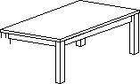 | 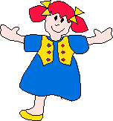 |  | 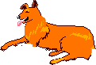 | 